“YouTube Transcripter”



A
PBL Report
submitted to the
SAGE University Bhopal, M.P.
In partial fulfillment of the requirements for award of the Degree of

B.Tech CSE Hons.

With specialization in

“Artificial Intelligence and Cyber Security and Forensics”

Submitted By- Under the Guidance of-
Aparna Anand (20BTA3ARI11008) Mr. Chandan Kumar
Koushiki Awasthi (20BTA3CSF10003) School of Advanced Computing
Aryan Dhanelia (20BTA3CSF10009)

SCHOOL OF ADVANCED COMPUTING
SAGE UNIVERSITY BHOPAL
June, 2022
 | SANJEEV AGRAWAL GLOBAL EDUCATIONAL (SAGE)  UNIVERSITY, BHOPAL

School of Advanced Computing

CERTIFICATE

This is to certify that the work embodies in this dissertation entitled " YouTube Transcripter " being submitted by Aparna Anand (20BTA3ARI11008), Koushiki Awasthi (20BTA3CSF10003) and Aryan Dhanelia (20BTA3CSF10009) for fulfilment of the requirement for the award of "BTech CSE Hons. AI and CSF" discipline to SAGE University, Bhopal (M.P.) during the academic year 2020-24 is a record of bonafide piece of work, undertaken by him under the supervision of the undersigned.

Head of School
Dr. Pinaki Ghosh
School of Advanced Computing

Supervisor
Mr. Chandan Kumar
School of Advanced Computing

SANJEEV AGRAWAL GLOBAL EDUCATIONAL (SAGE) UNIVERSITY, BHOPAL

School of Advanced Computing

CERTIFICATE OF APPROVAL

The Dissertation Entitled "YouTube Transcripter" being submitted by Aparna Anand (20BTA3ARI11008), Koushiki Awasthi (20BTA3CSF10003) and Aryan Dhanelia (20BTA3CSF10009) has been examined by us and is hereby approved for the award of “BTech CSE Hons.(AI and CSF) ", for which it has been submitted. It is understood that by this approval the undersigned do not necessarily endorse or approve any statement made, opinion expressed or conclusion drawn there in, but approve the dissertation only for the purpose for which it has been submitted.

(Internal Examiner) (External Examiner)

SANJEEV AGRAWAL GLOBAL EDUCATIONAL (SAGE) UNIVERSITY, BHOPAL

School of Advanced Computing

DECLARATION

I hereby declare that the work, which is being presented in this dissertation entitled "YouTube Transcripter" for fulfillment of the requirements for the award of degree of “BTech CSE Hons. (AI and CSF) “submitted in the School of Advanced Computing, M.P Bhopal, is an authentic record of my own work carried under the guidance of Dr. Gaurav Shrivastava. I have not submitted the matter embodied in this report for the award of any other degree.

I also declare that “A check for Plagiarism has been carried out on this dissertation and is found within the acceptable limit and report of which is enclosed herewith.”
Aparna Anand (20BTA3ARI11008)
Koushiki Awasthi (20BTA3CSF10003)
Aryan Dhanelia (20BTA3CSF10009)
Supervisor:-
Mr. Chandan Kumar
HoS/Dean Sign with seal
Sage University Bhopal

ACKNOWLEDGEMENT

We would like to express my heartfelt gratitude to our supervisor Mr. Chandan Kumar of , School of Advanced Computing, Bhopal who has encouraged us throughout the course of the project. His continuous support and motivation were the prime factors contributing to the timely and successful completion of this project.
We owe an enormous debt of gratitude to my project guide, Mr. Chandan Kumar, for guiding and inspiring us from the beginning through the end of this project with his intellectual advices and insightful suggestions. We truly appreciate and value his consistent feedback on our progress, which was always constructive and encouraging, and ultimately drove us to the right direction.
We also owe a great deal of thanks to all the faculty members of School of Advanced Computing for their valuable assistance, help and motivation throughout our project work.

Aparna Anand (20BTA3ARI11008)
Koushiki Awasthi (20BTA3CSF10003)
Aryan Dhanelia (20BTA3CSF10009)

TABLE OF CONTENT
S.NO | TITLE | PAGE NO
1. | FRONT PAGE
2. | CERTIFICATE | i
3. | APPROVAL CERTIFICATE | ii
4. | DECLARATION | iii
5. | ACKNOWLEDGEMENT | iv
6. | TABLE OF CONTENT | v
7. | LIST OF FIGURES | v
8. | ABSTRACT | vi
CHAPTER 1 INTRODUCTION |  | vii
CHAPTER 2 LITERATURE REVIEW |  | viii
CHAPTER 3 MATERIAL AND METHODS |  | ix
CHAPTER 4 System Design |  | x
CHAPTER 5 EXPERIMENTAL WORK |  | xi
CHAPTER 5 CONCLUSION AND FUTURE SCOPE |  | xv
 | REFRENCES | xvi

LIST OF FIGURES
Figure.NO | TITLE | PAGE NO.
Figure 1 | System Design | x
Figure 2 | Download Youtube video’s audio | xi
Figure 3 | Audio Speech Recognition with hugging face | xi
Figure 4 | Audio Chunking | xii
Figure 5 | Speech to Text Conversion | xiii
Figure 6 | Text Summarization | xiv
Figure 7 | Text Chunking before summarization | xiv

Abstract

Enormous number of video recordings are being created and shared on the Internet through out the day. It has become really difficult to spend time in watching such videos which may have a longer duration than expected and sometimes our efforts may become futile if we couldn’t find relevant information out of it. Summarizing transcripts of such videos automatically allows us to quickly look out for the important patterns in the video and helps us to save time and efforts to go through the whole content of the video.

This project proposes a video summarizing system based on natural language processing (NLP) and Machine Learning to summarize the YouTube video transcripts without losing the key elements. The quantity of videos available on web platforms is steadily expanding. The content is made available globally, primarily for educational purposes. Additionally, educational content is available on YouTube, Facebook, Google, and Instagram.

A significant issue of extracting information from videos is that unlike an image, where data can be collected from a single frame, a viewer must watch the entire video to grasp the context. This study aims to shorten the length of the transcript text of the given video. The suggested method involves retrieving transcripts from the video link provided by the user and then summarizing the text by using Hugging Face Transformers and Pipelining. The built model accepts video links and the required summary duration as input from the user and generates a summarized transcript as output.

According to the results, the final translated text was obtained in less time when compared with other proposed techniques. Furthermore, the video’s central concept is accurately present in the final text without any deviations..

INTRODUCTION
Enormous number of video recordings are being created and shared on the Internet through out the day. It has become really difficult to spend time in watching such videos which may have a longer duration than expected and sometimes our efforts may become futile if we couldn’t find relevant information out of it. Summarizing transcripts of such videos automatically allows us to quickly look out for the important patterns in the video and helps us to save time and efforts to go through the whole content of the video.
This project will allow us to have hands-on experience with state-of-the-art NLP techniques for abstractive text summarization and implement an interesting idea suitable for intermediates and a refreshing hobby project for professionals.
Various organizations today, be it online shopping, private sector organizations, government, tourism, and catering industry, or any other institute that offers customer services, are all concerned to learn their customer’s feedback each time their services are utilized. Now, consider that these companies are receiving an enormous amount of feedback and data every single day. It becomes quite a tedious task for the management to analyze each of these data points and come up with insights.
However, we have reached a point in technological advancements where technology can help with the tasks and we ourselves do not need to perform them. One such field that makes this happen is Machine Learning. Machines have become capable of understanding human language with the help of NLP or Natural Language Processing. Today, research is being done with the help of text analytics.
One application of text analytics and NLP is Text Summarization. Text Summarization Python helps in summarizing and shortening the text in the user feedback. It can be done with the help of an algorithm that can help in reducing the text bodies while keeping their original meaning intact or by giving insights into their original text.

LITERATURE SURVEY

Since the development of Digital multimedia, massive amounts of digital content have been posted every day via social platforms. For example: news, documentaries, movies, talk programmes, and sports. This vast amount of disparate content necessitates both processing time and memory. Extraction of condensed form of videos is necessary so that consumers may get the most information in the least amount of time. Reading is a hands-on activity, whereas watching is a passive one. When you're watching educational videos, the last thing you want to do is take notes and miss half of the information.

Transcripts of videos provide complete content while allowing viewers to completely participate in the video's vision without the worry of missing anything. The advantages of video transcripts are incalculable, whether you're a YouTube watcher or a video producer. The transcript is useful for doing modifications and capturing audio for legal documentation as the owner of a shared video, not to mention the time saved by talking it rather than typing it. There may be occasions when a video is not permitted or accessible, but a YouTube video transcript might readily serve as a trade saver. We can construct a brief and articulate summary of a long text content using artificial text summarizing technologies. These approaches can extract applicable details from the input text and use that information more quickly. Not only does this textual conversion lower the quantity of video data, but it also allows users to traverse through it. The users can have a quick glance at the summary of the YouTube video and know whether watching the video is worth their time and if the content in the video matches with the topics that they are looking for.

Automatic Text Summarization is one of the most exciting and challenging problems in the fields of Natural Language Processing and Machine Learning. Extractive and abstractive approaches are the two most common ways to summarise text. Extractive approaches depend only on extracting significant phrases from a document and later combining these significant phrases into a coherent summary. Abstractive approaches analyse the document of text and generate a coherent summary with new words and phrases just like humans do. In this paper, we have presented the previous work related to the problem statement and also described various text summarization techniques by emphasising more on abstractive text summarization methods.

TOOLS AND TECHNOLOGY

Python
Python is an interpreted high-level general-purpose programming language. Its design philosophy emphasizes code readability with its use of significant indentation. Its language constructs as well as its object-oriented approach aim to help programmers write clear, logical code for small and large-scale projects.
NLP
Natural language processing is a subfield of linguistics, computer science, and artificial intelligence concerned with the interactions between computers and human language, in particular how to program computers to process and analyze large amounts of natural language data.

EXPERIMENTAL WORK

Our project is divided in four parts

- Download youtube video’s audio

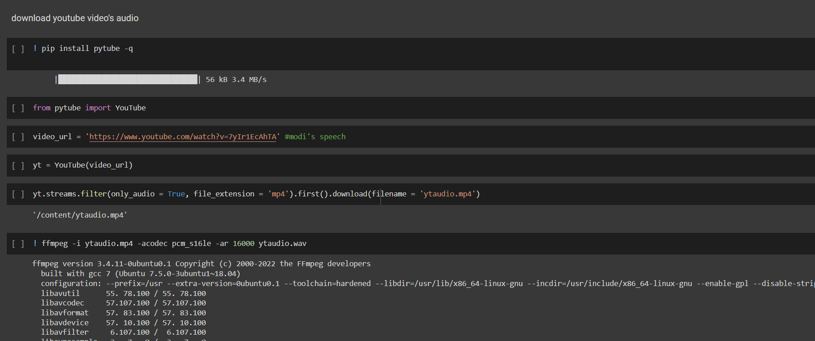
Figure 2

- Audio Speech Recognition with Hugging face

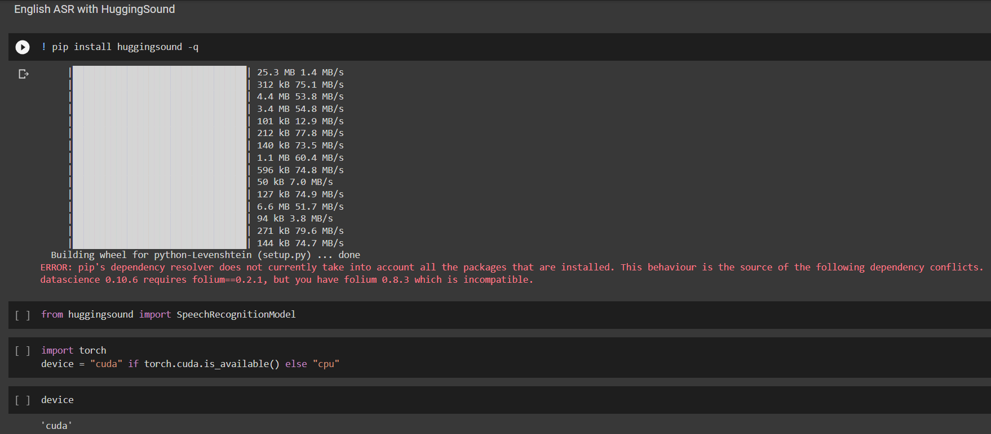
Figure 3

- Audio Chunking

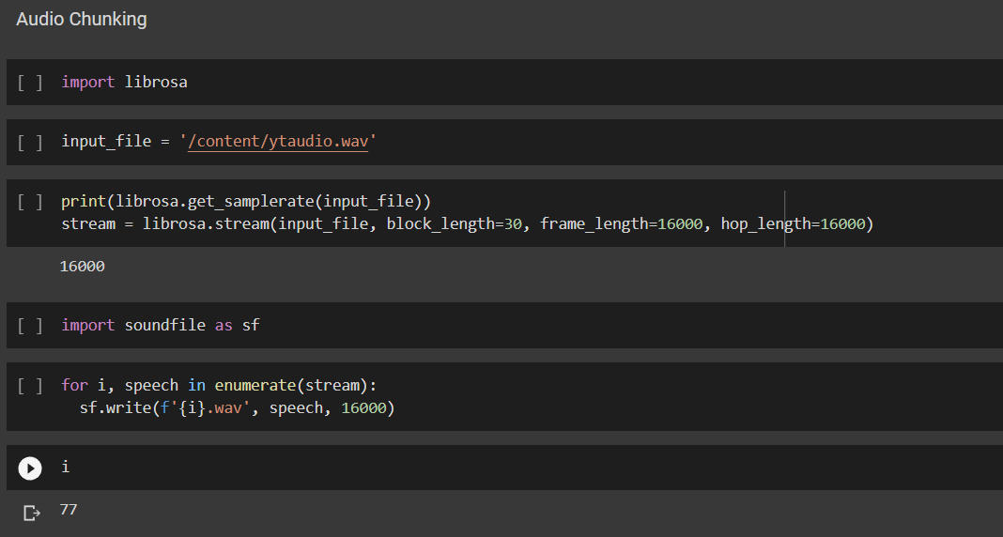
Figure 4

- Speech to Text Conversion

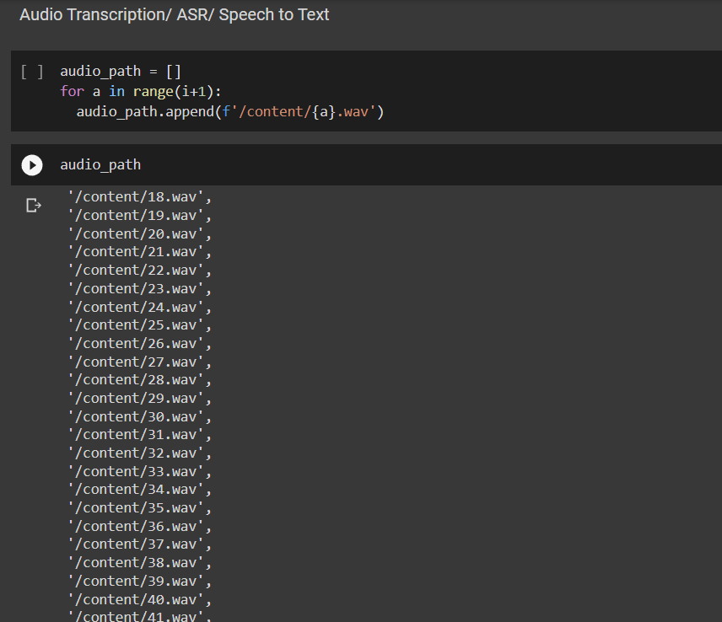
Figure 5

- Text Summarization

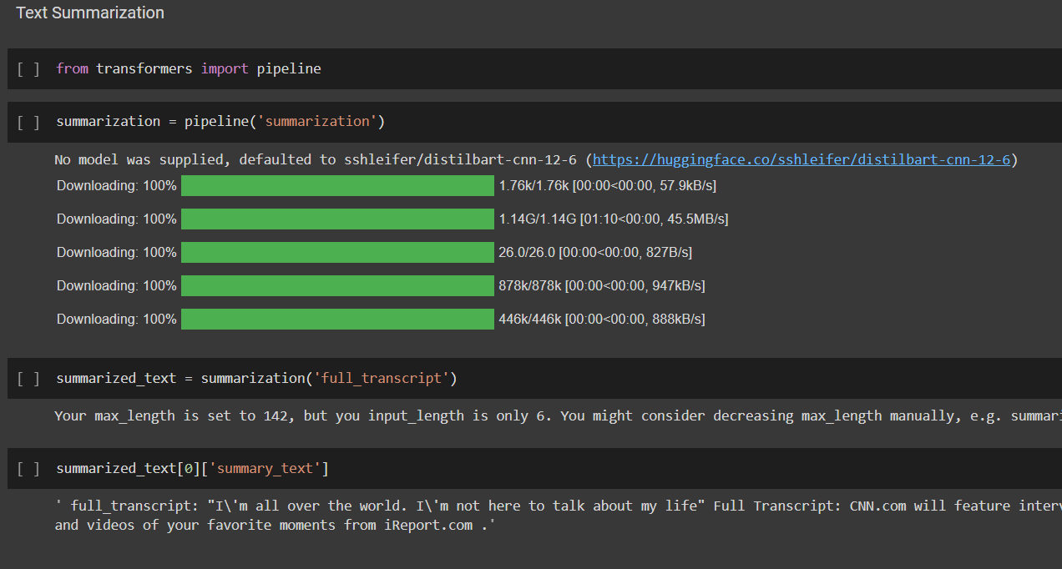
Figure 6

- Text Chunking before Summarization

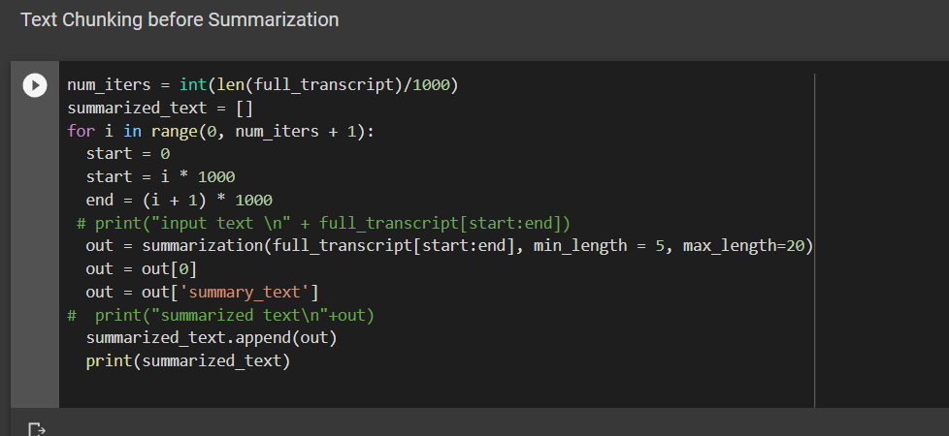
Figure 7

USE CASE DIAGRAM

Enter Youtube Video’s link

Display summary

user

Filter youtube video

Audio Chunking

Speech Text

admin

Text Summarization

CONCLUTION AND FUTURE SCOPE

The number of YouTube users in 2020 was approximately 2.3 billion and has been increasing every year. Every minute, 300 hours of YouTube videos are posted. It is frustrating and time consuming to search for the videos that contains the information we are actually looking for. For instance, there are many Ted Talk videos available online in which the speaker talks for a long time on a given topic, but it is hard to find the content the speaker is mainly focusing on unless we watch the entire video. Existing video summarization systems require strong prior technical knowledge. Machine learning based algorithms require high processing power. Summarizing video based on its subtitle is the fastest way of generating video summary, because dealing with text is easier and faster compared to training various videos using machine learning models. This paper presents the users a predominant advantage of producing summaries of YouTube videos. Various researches have been carried out to accomplish different modules such as: Text summarization, Transcript generation and translation. A brief summary of different text summarizations, Extractive Summarization and Abstractive Summarization has been described. Subsequently different models in abstractive summarization have also been described. The fundamental goal of this challenge is to develop a software that produces summaries of YouTube videos automatically to get the gist of entire video before watching it.
FUTURE SCOPE

The hearing-impaired individuals and the students are the groups of people in the society that would be benefitted the most with the Transcript Summarization of YouTube videos. The hearing-impaired people find it difficult to understand the videos without the transcripts or subtitles. It would be helpful for them if summary is generated even for the videos which do not have readily available transcripts. Summarising the transcripts of the YouTube videos would also help the students to pick lecture/tutorial videos based on their preferences. The concept of Transcript Summarisation can also be extended to other streaming services as well
REFERENCES

[1]https://medium.com/@darshanvano009/youtube-transcript-summarizer-4ad5618c8c25

[2] https://huggingface.co/spaces/jipenaflor/Youtube-Transcript-Summarizer
[3]https://www.analyticsvidhya.com/blog/2022/01/youtube-summariser-mini-nlp-project/
[4] https://ieeexplore.ieee.org/document/9751991
[5]https://medium.com/newolf-society/samuraiser-the-youtube-transcript-summarizing-extension-89434153d2bc

